**Short Term Trading Low Resistance Liquidity Runs Part 2**

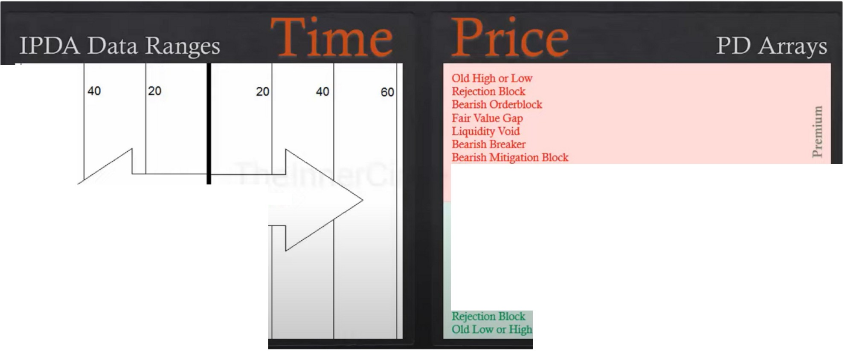

60

Look Back Cast Forward

**Market Price**

Bullish Mitigation Block Bullish Breaker Liquidity Void

Fair Value Gap

Bullish Orderblock

**PD Array Matrix**

What can be a consolidation on 1 timeframe can be a trending one in another

|  |  |  |
| --- | --- | --- |
|  |  |  |
|  |  |
| **OIIIU.& Blocll** | |  |
|  | |

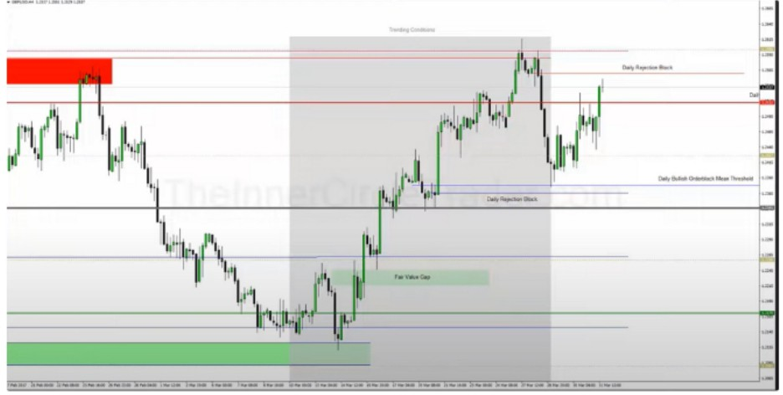

|  |  |
| --- | --- |
| ~ - --  **l** *..J:_ -, -* --2  *J11lJ* V\ I *. .(·*Jt  *)* | |
|  |  |
|  |

For one shot one kill were going to be focusing on the 4h chart, 4h chart is the easiest for one shot one kill and will give us all the insights

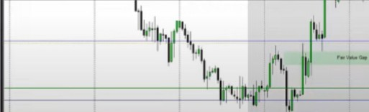

If we want to go long and it happens at a quadrant level you'll see high probability movement to an opposing level

The weekly range shaded in yellow Think about the power of 3

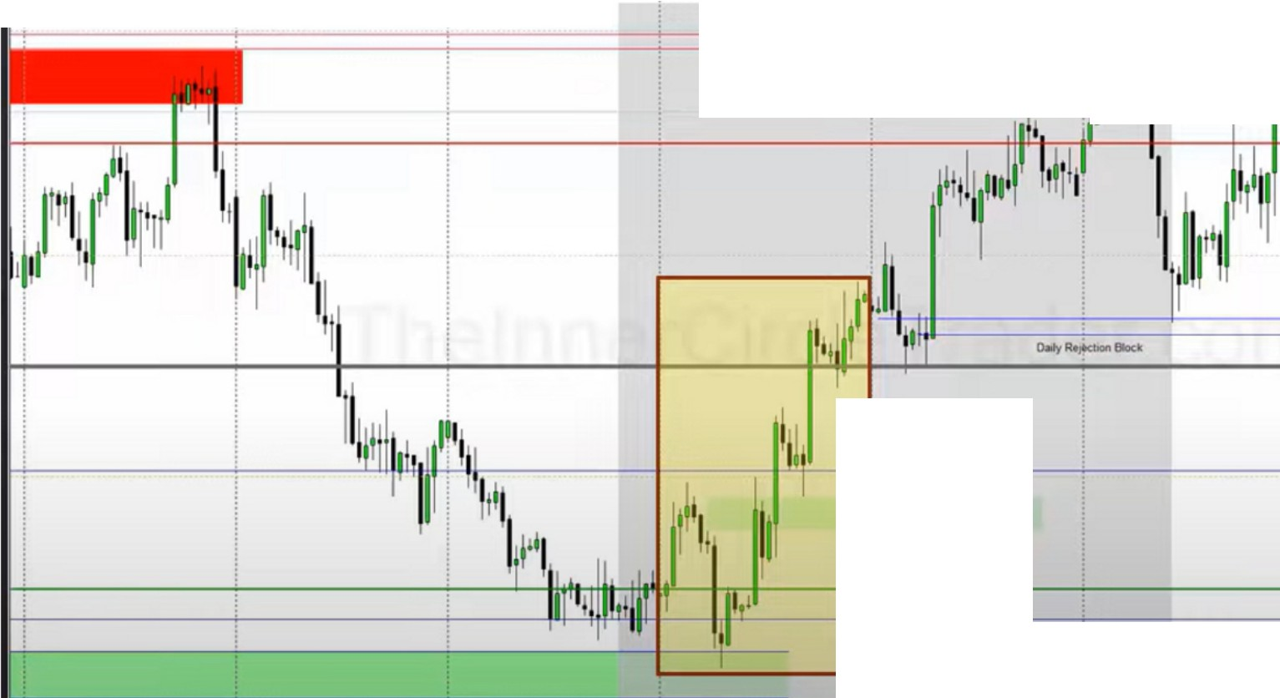

i-

--:--

' ...

! **Ctrl + Y for Weekly D1v1ders**

um

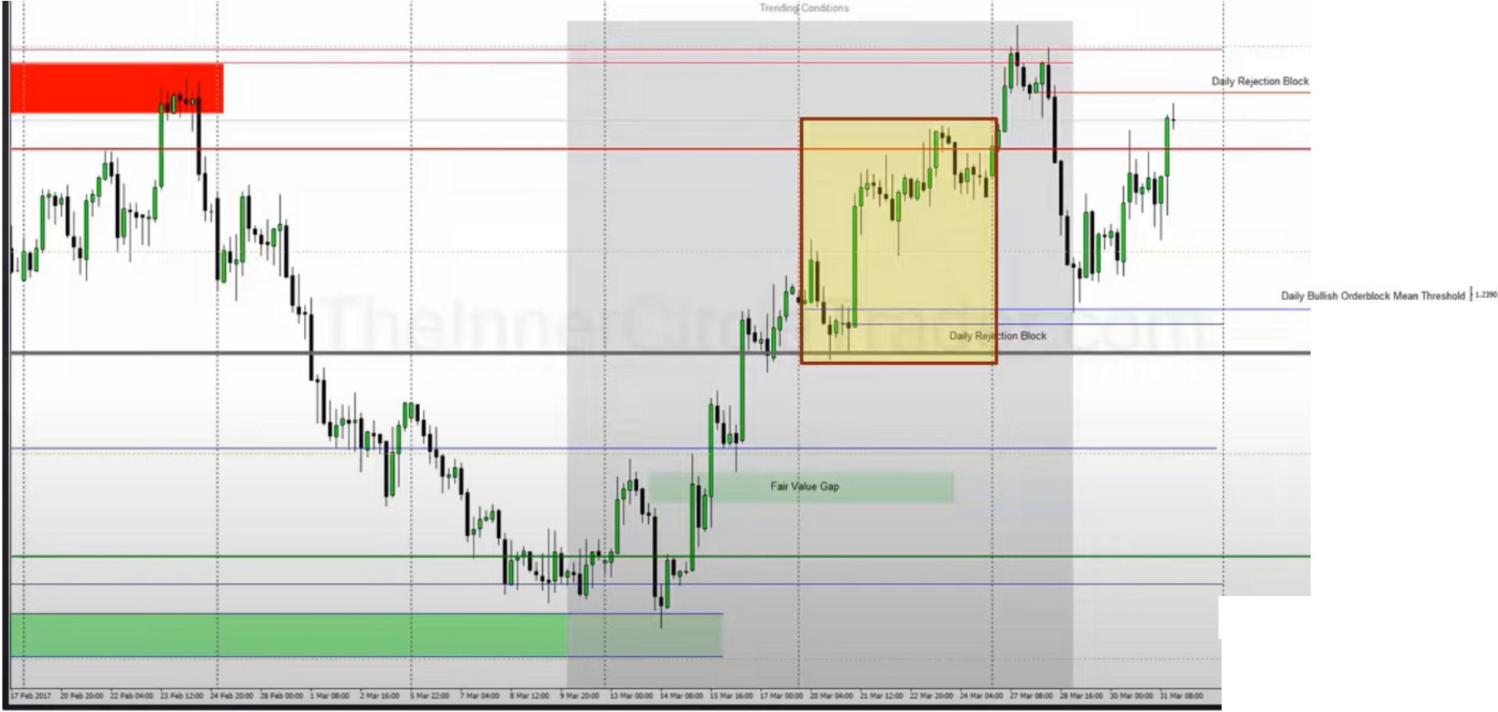

! Ctrl + y for Weekly DMders

·-

=•

And look at the response at the quadrant

It moves from logical discount to logical premium The quadrants act like magnets

If it breaks trough a quadrant it will likely reach for the level above or below ofc, depends on the direction

Where will price reach for when it is in a premium market and where will it reach for when it is in a discount market, ask yourself this every week. What PD arrays will it reach for?

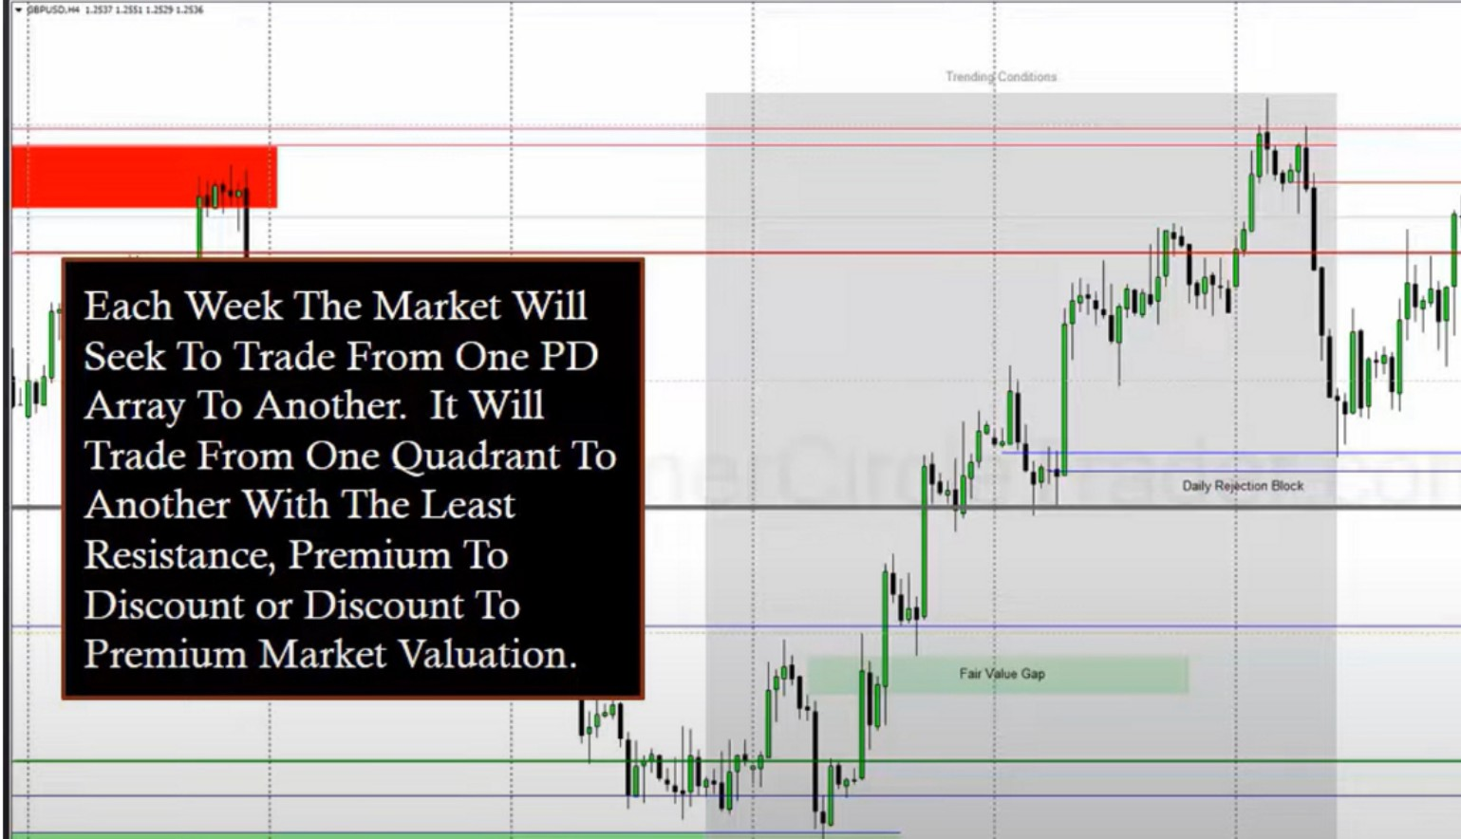

!**Ctrl + Y for Weekly DMders um**

By looking at the PD arrays on a 4h chart you can anticipate what the weekly range will do in a completed sence, what the market looks like after the close on friday. Try to anticipate what the weekly range will look like, this will build your anticipatory skills.

When price drops its not just looking for support, its looking for an old institutional orderflow level and its going to be in the form of a PD array

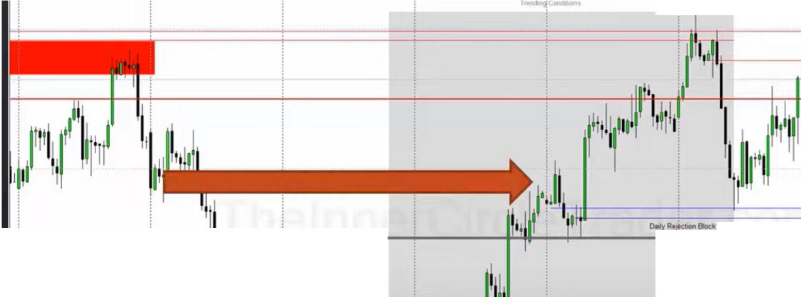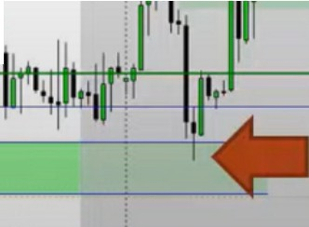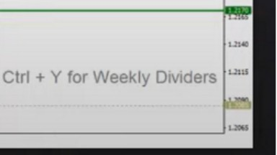

•

**USVUIII l,ll.'t1.aa**

1

* ,..... -

_ _._...,, **11,,** 1-,,,11

. **·11111**

1

4

.....,.. ,v_.., ,

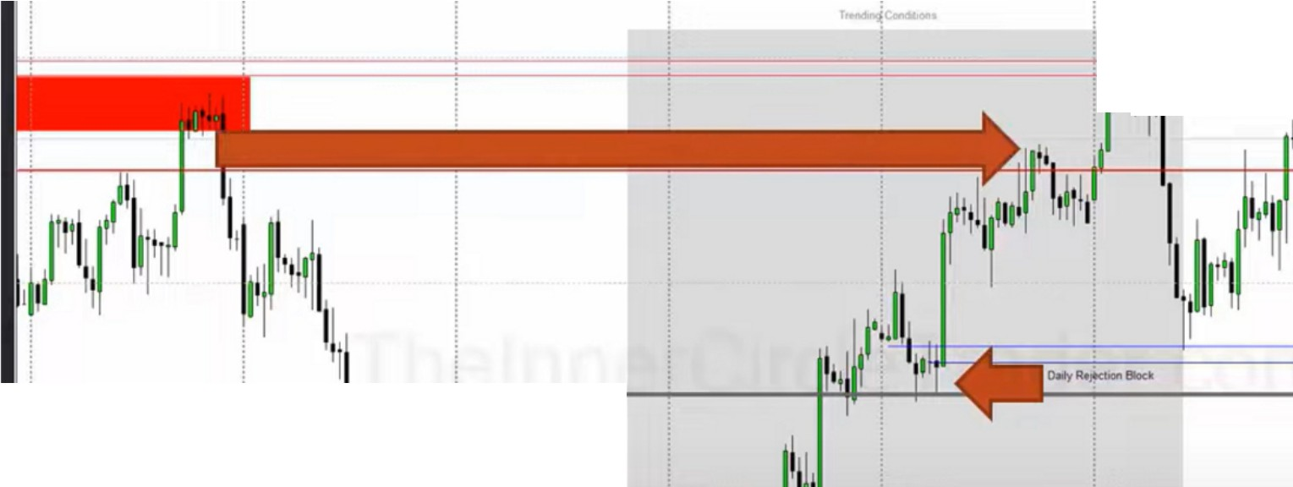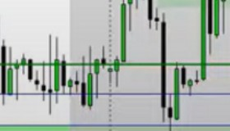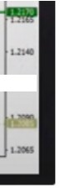

**JI**

**<**

**""'**

* f------- ----'--4 **111-'-'!**,**,**,**I-**-ffj-- ,-.v_..,----

. **11·11**

I,,

iCtrl + Y for Weekly Otvtders "

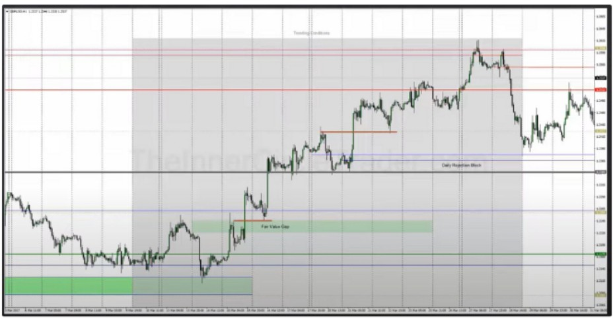 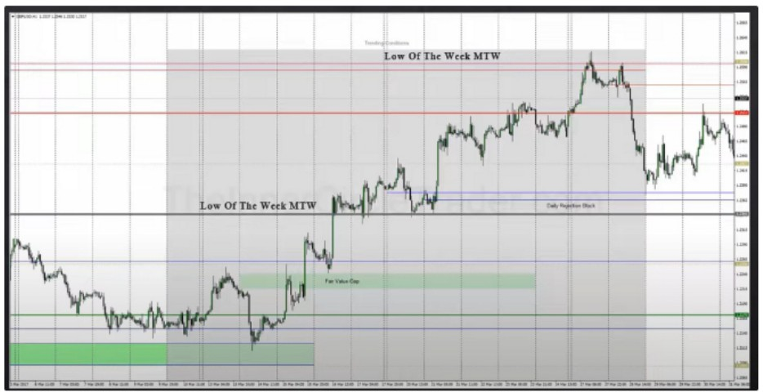

Anything less than a 1h chart really reduces the effectiveness because what youre looking for is that impulse price swing to complete the weekly range. So docus on the 4h for levels you want to key off and with the 1h we can look at it from a day to day basis

When bullish we look for the low of the week to be on monday tuesday or wednesday Notice how the lows of the week trade from a logical discount array

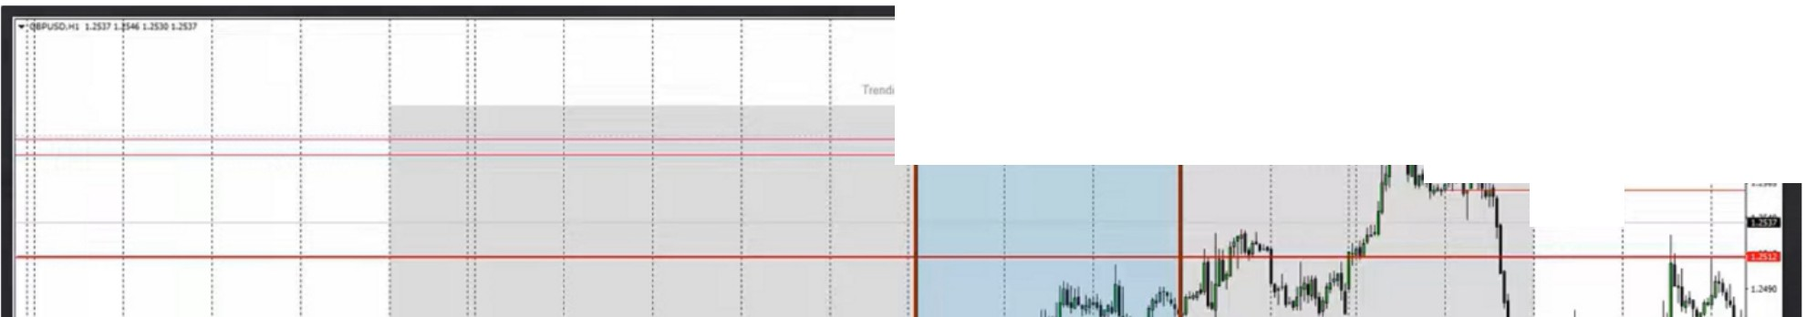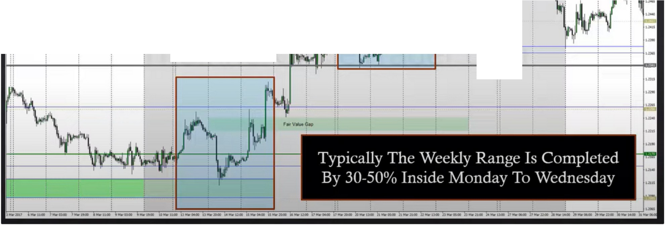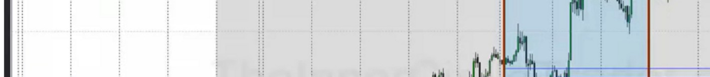

:

:

**I.ow Of The Week MTW**

°"'-""'

|  |  |  |  |  |  |
| --- | --- | --- | --- | --- | --- |
| **-1**  **iow Of The We k MTW** | �  .. | !.   * · i | I.  1 | !.  *I* |  |

By london close on wednesday

This means, if we do not catch the long for a bullish week on MTW, don't expect a massive move on thursday or friday

Arjo I Twitter, lnstagram I Linktree

Linktree. Make your link do more. https://t.co/HhmmTN1fUI

JavaScript is not available.

*"!I* https://twitter.com/arjoio